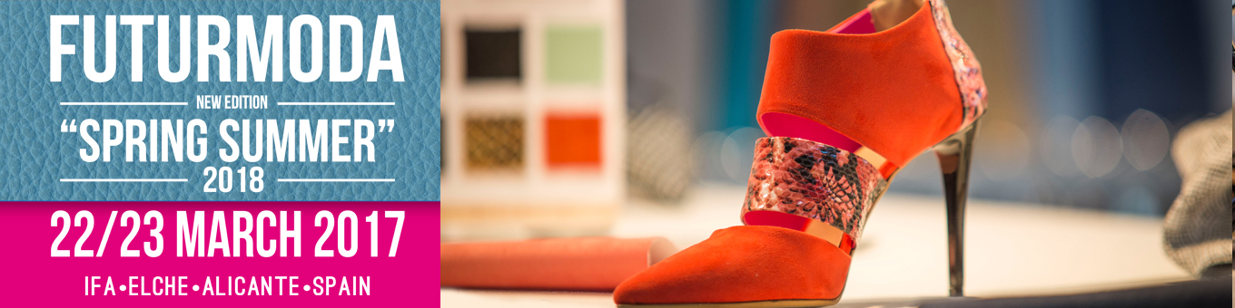
FUTURMODA SPRING SUMMER 2018
A great exhibition offer with a clear international projection.

Thursday, January 26, 2017.
The footwear component sector represents a very innovative industry with its own personality, which gained by virtue of decades of work, entrepreneurial effort and improvement has been able to make a solid gap at the international level.

In recent years the profound changes that the shoe industry has undergone have affected it too, calling into question its competitiveness. However, the Spanish sector of footwear components as a whole has been able to evolve towards a much more productive and innovative sector model. As a result of this innovative evolution, the fair of the components has not stopped growing.

FUTURMODA, the International Leather Show, Components and Machinery for Footwear and Leather goods will be held in March its 37th edition presenting one of the most competitive offers at national level and one of the most complete at European level.

Given the continuous growth of the fair and the good pace of commercialization, FUTURMODA will surpass in March the 10,000 m2 of exhibition, becoming an unavoidable event for all manufacturers and designers.

In this edition we will have a large number of exhibitors, coming from Spain, Italy, Portugal and Turkey.

The reasons why you have to visit the fair are many; in this article we highlight five:
- Offer. Futurmoda welcomes the most important companies in the European scene.

- Quality. The collections presented at the fair are exclusive and of the highest quality.

- Promotion. Futurmoda contributes to reinforce the image of the companies and to promote the opportunity to generate business.

- Project. New areas of exhibition aimed at enhancing the exhibition offer of the components.

- Fashion. Futurmoda becomes the meeting place for designers and manufacturers who want to innovate.

Futurmoda designs each edition much more attractive spaces. In the last edition of the Spanish fair of the components, the Spanish Association of Companies of Components for the Footwear presented a concept of new fair, avant-garde and very natural, in that same line AEC is working to promote this project with the inclusion of new Exhibition areas, among which the ecological components will be highlighted.

Futurmoda will start on 22 and 23 March a new projection where the main protagonist will be the innovation.

